Department of Computing

School of Electrical Engineering and Computer Science

CS-250: Data Structure and Algorithms
Class: BSAI 2A

Lab 2: Pointers in C++

Date: 16th September 2026
Time: 10:00 am – 12:50 pm

Lab Instructor: Urooj Akmal
MAIRA QAMAR
551768

Lab 2: Pointers in C++

Introduction
This lab is about the pointers. In C++, a pointer refers to a variable that holds the address of another variable. Like regular variables, pointers have a data type. For example, a pointer of type integer can hold the address of a variable of type integer. A pointer of character type can hold the address of a variable of character type.
Objectives
This lab will revise the old concepts taught to the students in the previous semesters.
Tools/Software Requirement
- Visual Studio C++ (or any standard C++ IDE such as Code::Blocks, CLion, or g++ compiler).
Description
Pointers are used to point towards a particular memory address. In this lab we will use the pointers and perform task with the help of them.

Lab Tasks
Task 1
Write code to find the memory in bytes occupied by int, long, double, float and char.

Code:
#include <iostream>
using namespace std;
int main ()
{
cout << "Size of CHAR: " << sizeof(char) << " byte(s)\n";
cout << "Size of INT: " << sizeof(int) << " byte(s)\n";
cout << "Size of DOUBLE: " << sizeof(double) << " byte(s)\n";
cout << "Size of FLOAT: " << sizeof(float) << " byte(s)\n";
cout << "Size of Long: " << sizeof(long) << " byte(s)\n";
}

OUTPUT:
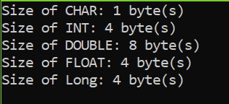
Task 2
Consider the following program and answer the questions.
void main()
{
int a, *pa; // Statement 1
pa = &a; // Statement 2
cout<<"pa = &a --> pa = "<<pa<<endl<<endl;
pa = pa + 1; // Statement 3
cout<<"pa = pa + 1 --> pa = "<<pa<<endl<<endl;
pa = pa + 3; // Statement 4
cout<<"pa = pa + 3 --> pa = "<<pa<<endl<<endl;
pa = pa - 1; // Statement 5
cout<<"pa = pa - 1 --> pa = "<<pa<<endl<<endl;
}
Output:
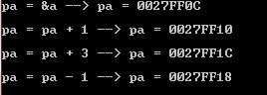
- Why does the memory address stored in pointer “pa” vary by 4?
EXPLANATION:
Why it changes by 4: Pointers store locations in memory, not just standard numbers. Because pa is set to point to an integer—and an int takes up 4 bytes of space—adding 1 to the pointer tells the compiler, "move to the next available spot in memory," which is 4 bytes over.
- Will the address still vary by 4 if the data type of the above mentioned code changed from “int” to “long”? Explain your answer.
EXPLANATION:
If changed to long: On most modern 64-bit platforms (like Mac or Linux), a long takes up 8 bytes, so the address would jump by 8 each time. On standard Windows or 32-bit setups, a long is still 4 bytes, so it would remain at 4.
- If we try to multiply the address pointed to by “pa” what will happen? Is this logically or programmatically correct? Attach screen shot of the output you get when you try this multiplication.
EXPLANATION:
Multiplying pointers: If you type pa * 2 or pa * pa, the code won't even compile—the compiler will throw an error. C++ simply doesn't allow pointer multiplication. Practically speaking, multiplying a RAM memory location is useless because the resulting location would be random and completely meaningless.
Task 3

int list[5]={3,6,9,12,15};
int *pArr= list;

Your task is to write a piece of code that prints all values stored in the array list using only pointer variable pArr. Do not use the conventional way of printing values by numbering indexes.

Code:
#include <iostream>
using namespace std;
int main ()
{
int list[5] = { 3,6,9,12,15 };
int* pArr = list;
for (int i = 0; i < 5; i++)
{
cout << *(pArr + i) << "\n";
}
return 0;
}

OUTPUT:
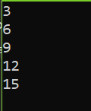
Task 4
Write output of the following C++ codes in your document without executing it.
Example code a)
int x[4] = {0,4,6,9};
int *p, a=3;
p=x;
(*p)++;
cout<<*p<<endl;
cout<<*(p+1)<<endl;
p++;
*p=*p+a;
cout<<*p<<endl;
p=p+2; //What is happening here?
cout<<*p<<endl;

Output:
1
4
7
8

Example code b)
int a, *p, *q;
int arr[4]= {0};

p=arr;
q=p;

*p=4;

for(int i=0; i<3; i++){
a=*p;
p++;
*p=(a+i);
}
for (int j=0; j<4; j++){
cout<<*q<<" ";
q++;
}

Output:

4
4
5
7

Task 5

int a=5, b=10;
int *pa=&a; //pa and pb are pointer variables of type int.
int *pb=&b;

int **ppa=&pa; //ppa and ppb are called double pointers or pointers-to-pointers.
int **ppb=&pb;

- Write code of a function that swaps values of variables a and b. Input to the function should be the address of both the variables.

Code:
#include <stdio.h>
void swapByAddress(int* px, int* py) {
int temp = *px;
*px = *py;
*py = temp;
}

int main() {
int a = 5, b = 10;

swapByAddress(&a, &b);

printf("a = %d, b = %d\n", a, b);
return 0;
}

Output:
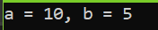

- Write code of a function that swaps values of the variables a and b using pointer-to-pointer variables ppa and ppb.
Code:
#include <stdio.h>

void swapByDoublePointer(int** ppx, int** ppy) {
int temp = **ppx;
**ppx = **ppy;
**ppy = temp;
}

int main() {
int a = 5, b = 10;
int* pa = &a;
int* pb = &b;
int** ppa = &pa;
int** ppb = &pb;

swapByDoublePointer(ppa, ppb);

printf("a = %d, b = %d\n", a, b);
return 0;
}

Output:
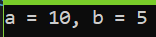
Task 6

- A teacher records marks for a group whose number of students and number of subjects are entered at runtime. Each row represents a student and each column a subject.
- Read and validate rows and cols before allocation. Allocate an int** marks array of row pointers, then allocate cols integers for each row.
- Read marks from 0 to 100 and display the matrix. Assume entered marks are valid. Use *(*(marks + r) + c) in at least one complete input or output loop.
- Calculate each student’s total. Display the student with the highest total and that total. If totals tie, report the first student. Use student numbers starting at 1.
- Delete all rows, then delete the row-pointer array and set marks to nullptr. Explain what would remain allocated if only delete[] marks; were executed.
- For two students and three subjects, sketch the pointer variable, the array of two row pointers and the two separately allocated rows. Label marks, marks[0] and marks[0][0].
Hint: determine the first student’s total before comparing other students. Keep separate variables for the best total and its student number.
Input by row | Expected result
2 × 3: 50 60 70 / 80 40 90 | Totals: 180, 210; top student: 2
2 × 2: 40 60 / 50 50 | Totals: 100, 100; top student: 1
1 × 1: 75 | Total: 75; top student: 1

Code:
#include <iostream>
using namespace std;

int main()
{
int rows, cols;

// 1. Read and validate rows and columns
do
{
cout << "Enter number of students: ";
cin >> rows;
} while (rows <= 0);

do
{
cout << "Enter number of subjects: ";
cin >> cols;
} while (cols <= 0);

// 2. Allocate array of row pointers
int** marks = new int* [rows];

// Allocate columns for each row
for (int r = 0; r < rows; r++)
{
marks[r] = new int[cols];
}

// 3. Read marks
for (int r = 0; r < rows; r++)
{
cout << "Student " << r + 1 << ":\n";

for (int c = 0; c < cols; c++)
{
do
{
cout << "Enter mark for subject " << c + 1 << " (0-100): ";
cin >> marks[r][c];

if (marks[r][c] < 0 || marks[r][c] > 100)
{
cout << "Invalid mark! Please enter a value between 0 and 100.\n";
}

} while (marks[r][c] < 0 || marks[r][c] > 100);
}
}

// Display matrix
cout << "\nMarks Matrix:\n";

for (int r = 0; r < rows; r++)
{
for (int c = 0; c < cols; c++)
{
cout << marks[r][c] << " ";
}

cout << endl;
}

// 4. Calculate totals
int bestTotal = 0;
int bestStudent = 1;

// Find first student's total first
int total = 0;

for (int c = 0; c < cols; c++)
{
total += marks[0][c];
}

bestTotal = total;

// Compare remaining students
for (int r = 1; r < rows; r++)
{
total = 0;

for (int c = 0; c < cols; c++)
{
total += *(*(marks + r) + c);
}

cout << "Student " << r + 1 << " total: " << total << endl;

if (total > bestTotal)
{
bestTotal = total;
bestStudent = r + 1;
}
}

// Display first student's total too
int firstTotal = 0;

for (int c = 0; c < cols; c++)
{
firstTotal += marks[0][c];
}

cout << "Student 1 total: " << firstTotal << endl;

cout << "\nHighest total: " << bestTotal << endl;
cout << "Top student: " << bestStudent << endl;

// 5. Delete every separately allocated row
for (int r = 0; r < rows; r++)
{
delete[] marks[r];
}

// Delete row-pointer array
delete[] marks;

// Set pointer to null
marks = nullptr;

return 0;
}

OUTPUT:
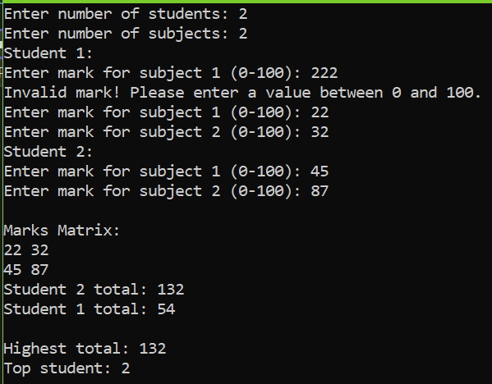

Task 7
A new student joins after the marks have been entered. Write a separate program that reads n (1–10), allocates n marks and then stores one additional mark.
1. Allocate a second block of n + 1 integers. Copy the original n values into it using pointer notation. Read the new mark into the final position.
2. Release the old block. Make the original pointer refer to the new block, update the stored size, and display all values.
3. Release the final block exactly once. Explain why changing n alone does not increase the old block’s capacity.
Check: n = 3; marks 45 60 75; new mark 90 → 45 60 75 90. Also test n = 1; mark 0; new mark 100 → 0 100.
Hint: allocate → copy → append → delete old block → update pointer and size. Other pointers to the old block then become dangling.
CODE:

#include <iostream>
using namespace std;

int main()
{
int n;

// Read and validate n
do
{
cout << "Enter number of marks (1-10): ";
cin >> n;

} while (n < 1 || n > 10);

// Allocate original array
int* marks = new int[n];

// Read original marks
cout << "Enter " << n << " marks:\n";

for (int i = 0; i < n; i++)
{
cin >> marks[i];
}

// Allocate new block with one extra space
int* newMarks = new int[n + 1];

// Copy original values using pointer notation
for (int i = 0; i < n; i++)
{
*(newMarks + i) = *(marks + i);
}

// Read new mark into final position
cout << "Enter new mark: ";
cin >> *(newMarks + n);

// Release old block
delete[] marks;

// Make original pointer point to new block
marks = newMarks;

// Update size
n = n + 1;

// Display all values
cout << "\nAll marks: ";

for (int i = 0; i < n; i++)
{
cout << *(marks + i) << " ";
}

cout << endl;

// Release final block exactly once
delete[] marks;

// Reset pointer
marks = nullptr;

return 0;
}
OUTPUT:
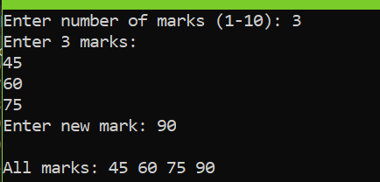
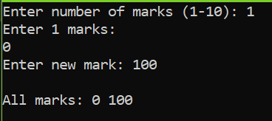
Task 8

The following fragment is intended to read and display three integers. Inspect it before running it; its current behaviour is undefined.
int n = 3;
int* values = new int[n];
for (int i = 0; i <= n; i++)
cin >> values[i];
delete values;
cout << values[0];
- Identify three errors. For each, state the problem and explain its consequence.
The loop is:
ERROR 1:
for (int i = 0; i <= n; i++)
For n = 3, i becomes:
0
1
2
3
But the valid indexes are only:
0
1
2
So: values[3] is outside the allocated array.

ERROR 2:
The memory was created using: new int[n]
Therefore it must be released using delete[] values NOT delete values.
- delete is for a single object.
- delete[] is for an array.

ERROR 3:

The program does:
delete values;
and then:
cout << values[0];
Once the memory has been deleted, values points to memory that is no longer valid.
This is called a dangling pointer.
You should display the values before deleting the array.
Then:
delete[] values;
values = nullptr;

- Write a corrected complete program that reads and displays all three integers, releases the allocation correctly and resets the pointer. Test with 4 5 6.
CODE:

#include <iostream>
using namespace std;

int main()
{
int n = 3;

// Allocate memory for 3 integers
int* values = new int[n];

// Read three integers
cout << "Enter 3 integers:\n";

for (int i = 0; i < n; i++)
{
cin >> values[i];
}

// Display all three integers
cout << "Values: ";

for (int i = 0; i < n; i++)
{
cout << values[i] << " ";
}

cout << endl;

// Release the array
delete[] values;

// Reset pointer
values = nullptr;

return 0;
}

OUTPUT:

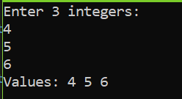
Briefly distinguish an out-of-bounds access, a dangling pointer and a memory leak. Explain why a program appearing to run successfully does not prove its memory accesses are valid.

Deliverables
Compile a single word document by filling in the solution part and submit this Word file on LMS. The name of word document should follow this format. i.e. YourFullName(reg)_Lab#. You must show the implementation of the tasks in a complete Word document to get your work graded. You must also submit this Word document on the LMS.
Note: Students are required to upload the lab on LMS before deadline.
Use proper indentation and comments. Lack of comments and indentation will result in deduction of marks.

Lab Rubrics
Assessment | Doesn’t meet Expectation  (1-2) | Meets Expectation  (3-4) | Exceeds Expectation  (5) | Marks
Software Problem Realization  (CLO2 – PLO2) | The Student is unable to understand and outline the problem and doesn’t use the relevant method to solve it. | The student requires some guidance to completely comprehend the problem and to differentiate the data structure and algorithm comprehensively. | The student fully understands the given problem, is able to analyze the relevant method to solve it, and develops a detailed program flow.
Software Tool Usage  (CLO3 – PLO5) | The student has no idea on how to use the basic tools of the software. The codes have syntax errors, and parts of the codes are missing. Also, they are unable to imitate the required output | The student has a limited command on the basic tools of the software and operated it under supervision. The codes are correct in terms of their syntax, however, the program output is not always correct. | The student has full command on various tools available in the software. Furthermore, his/her coding is complete and functional, and the program output is correct. Moreover, they can easily manipulate the code to design a particular solution
Ethics and Adherence to Laboratory Safety Rules  (CLO4 - PLO 8) | The student does not behave according to the professional ethics by following ethical norms applicable to the software industry such as acknowledgement while using publicly available data/ code. Disturbs the lab environment, doesn’t take care of safety measures, and/or isn’t punctual. | The student partially demonstrate their commitment to professional ethics by following ethical norms applicable to the software industry such as referencing and acknowledgement while using publicly available data/ code. Exhibits better behavior, works by taking into account the safety measures, and is punctual. | The student clearly express the commitment to professional ethics by following ethical norms applicable to the software industry such as referencing and acknowledgement while using publicly available data/ code. Encourages others to maintain lab decorum, and alerts them to follow safety measures.

